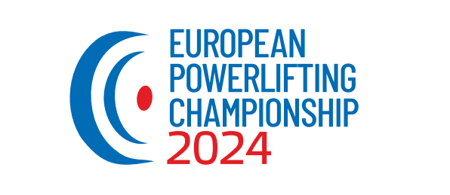

WUAP EUROPEAN CHAMPIONSHIP

Powerlifting & Benchpress & Deadlift

RAW and EQUIPPED
11.june – 15.june 2024

CITY SPORTS HALL
Rybníkova 576/15, Trnava/SLOVAKIA
Organizer:
World United Amateur Powerlifting (WUAP),
AWPC-Slovakia
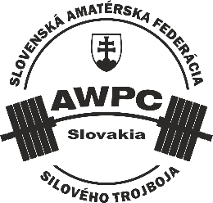
Promoter:
Rudolf Siska Mail: rudo.siska@gmail.com
Phon-Nr.: +421 903 651 672
Facebook: Rudolf Siska
Rules:
The European Championschip is organised and will be held by the WUAP rules, Level 1.1.2023.
These rules are available on the official site of WUAP: www.wuap-powerlifting.com
Lifting Schedule:

Tuesday, 11.06.2024

09:00 - Opening ceremony
09:30 Start - RAW powerlifting - men - Teen & Junior

Wednesday, 12.06.2024

09:00 Start - RAW powerlifting - women's - all categories
- RAW powerlifting - men - Masters

Thursday, 13.06.2024

09:00 Start - RAW powerlifting - men - Open
- EQ Powerlifting - all competitors (men & women)

Friday, 14.06.2024

09:00 Start - RAW benchpress - all competitors (men & women)

Saturday, 15.06.2024
09:00 Start - EQ benchpress - all competitors (men & women)
- F8 benchpress - all competitors (men & women)
- RAW deadlift - all competitors (men & women)
- EQ deadlift - all competitors (men & women)

Daily starting lists and division of groups will be published on the day of the competition after 08:00, after the weighing.

Competitors start in the appropriate category - according to the valid ID.

Important!!!

The schedule of competitions and weigh-in times is provisional and may change as applications are received. The organizer reserves the right to update the championship program after the application deadline.
Necessary changes will be announced on the WUAP website and Facebook.
Each starter is responsible for informing himself about possible changes to competition times after the registration deadline.
Weight-in Schedule:

Monday, 10.06.2024
15:00 – 19:00 (for Tuesday competitor)

Tuesday, 11.06.2024
06:30 – 08:00 (for Tuesday competitors)
15:00 – 19:00 (for Wednesday competitor)

Wednesday, 12.06.2024
06:30 – 08:00 (for Wednesday competitors)
15:00 – 19:00 (for Thursday competitors)

Thursday, 13.06.2024
06:30 – 08:00 (for Thursday competitors)
15:00 – 19:00 (for Friday competitors)

Friday, 14.06.2024
06:30 – 08:00 (for Friday competitors)
15:00 – 19:00 (for Saturday competitors)

Saturday, 15.06.2024
06:30 – 08:00 (for Saturday competitors)

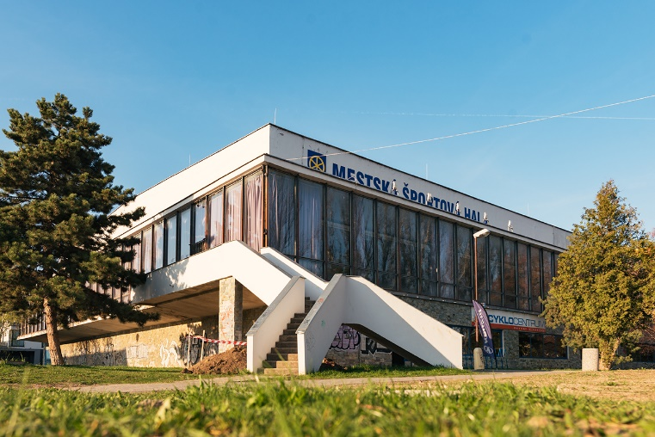

Entry fee:

First event:
75 € Open & Master,
50 € Teens & Junior

Additional event:
50 € /event Open & Master,
35 € /event, Teens & Junior

Entryform:

ATTENTION!!!

REGISTRATION FORM FOR ALL ATHLETES WHOSE COUNTRIES ARE NOT MEMBERS OF THE WUAP:

Individual form: …………………………………………
​

REGISTRATIONS FOR ALL ATHLETES OUT:
Austria, Germany, Slovakia, Czech Republic, Hungary, Poland, Switzerland, Italy, Croatia, Russia, Montenegro, Slovenia, Latvia, Ukraine, Bosnia and Herzegovina, Armenia, Serbia
ARE ONLY POSSIBLE VIA THEIR RESPECTIVE NATIONAL REPRESENTATIONS.

Team form: .....................................................

INDIVIDUAL ENTRIES FROM THESE COUNTRIES ARE NOT ALLOWED AND WILL BE REJECTED!

Deadline for the entry forms and fees: 10.May 2024
After 10.05.2024 no late entrys will be acceptet!

All lifters must pay their entry fees to their national federation.
The national federation is responsible for submitting the team list and team payment by the closing date.

All entry fees must be paid in Euro for this event.

Information for the bank transfer of the entry fee:

Account name: Matúš Albert
Bank: Fio banka
BIC Code: FIOZSKBAXXX
IBAN: SK95 8330 0000 0024 0277 2870

Information about parking in the city of Trnava and around the sports hall:

Last year, the parking policy in the city of Trnava was changed.
It is no longer possible to park for free anywhere. The city is divided into zones, which are charged according to whether the zone is in the center, near the center, or outside the center - in residential areas.
Parking tickets can be purchased from machines (coins - payment card) or via the application.
The zones are constantly controlled by the city police!
Please be vigilant to avoid unnecessary fines :)

Information about accommodation:
Accommodation capacity in the city of Trnava is more than 500 beds. Other accommodation options are in nearby towns and villages near Trnava.
You can also find information about affordable accommodation on the website of the city of Trnava, which also contains other useful information about transport, parking as well as about cultural monuments and gastronomic establishments

https://www.vitajtevtrnave.sk/en/accommodation/1?search=true

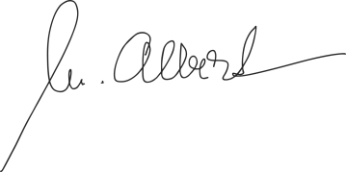
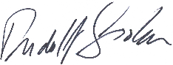

Rudolf Siska Matúš Albert
promoter AWPC-Slovakia president

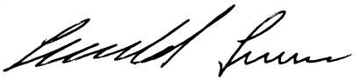
Franz Seewald Meinhard Schröder
WUAP vice president WUAP vice president

Approved in Trnava, 20.01.2024

